GET DATA
/TYPE=XLS
/FILE='C:\Users\EFILGUER\Downloads\gss2004.xls'
/SHEET=name 'gss2004'
/CELLRANGE=FULL
/READNAMES=ON
/DATATYPEMIN PERCENTAGE=95.0.
EXECUTE.
DATASET NAME DataSet1 WINDOW=FRONT.
GRAPH
/HISTOGRAM=wwwhr.

Graph

Notes
Output Created |  | 16-JAN-2019 16:33:46
Comments
Input | Active Dataset | DataSet1
Input | Filter | <none>
Input | Weight | <none>
Input | Split File | <none>
Input | N of Rows in Working Data File | 575
Syntax |  | GRAPH  /HISTOGRAM=wwwhr.
Resources | Processor Time | 00:00:01.34
Resources | Elapsed Time | 00:00:00.86

[DataSet1]

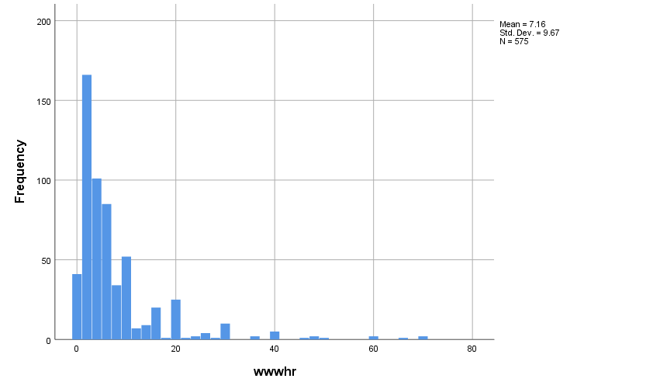

EXAMINE VARIABLES=emailhr BY sex
/PLOT BOXPLOT STEMLEAF HISTOGRAM NPPLOT
/COMPARE GROUPS
/STATISTICS DESCRIPTIVES EXTREME
/CINTERVAL 95
/MISSING LISTWISE
/NOTOTAL.

Explore

Notes
Output Created |  | 16-JAN-2019 16:38:58
Comments
Input | Active Dataset | DataSet1
Input | Filter | <none>
Input | Weight | <none>
Input | Split File | <none>
Input | N of Rows in Working Data File | 575
Missing Value Handling | Definition of Missing | User-defined missing values for dependent variables are treated as missing.
Missing Value Handling | Cases Used | Statistics are based on cases with no missing values for any dependent variable or factor used.
Syntax |  | EXAMINE VARIABLES=emailhr BY sex  /PLOT BOXPLOT STEMLEAF HISTOGRAM NPPLOT  /COMPARE GROUPS  /STATISTICS DESCRIPTIVES EXTREME  /CINTERVAL 95  /MISSING LISTWISE  /NOTOTAL.
Resources | Processor Time | 00:00:01.70
Resources | Elapsed Time | 00:00:00.97

sex

Case Processing Summary
 | sex | Cases
 | sex | Valid |  | Missing |  | Total
 | sex | N | Percent | N | Percent | N | Percent
emailhr | Male | 239 | 100.0% | 0 | 0.0% | 239 | 100.0%
emailhr | Female | 336 | 100.0% | 0 | 0.0% | 336 | 100.0%

Descriptives
 | sex |  |  | Statistic | Std. Error
emailhr | Male | Mean |  | 6.33 | .615
emailhr | Male | 95% Confidence Interval for Mean | Lower Bound | 5.12
emailhr | Male | 95% Confidence Interval for Mean | Upper Bound | 7.54
emailhr | Male | 5% Trimmed Mean |  | 4.85
emailhr | Male | Median |  | 2.00
emailhr | Male | Variance |  | 90.364
emailhr | Male | Std. Deviation |  | 9.506
emailhr | Male | Minimum |  | 0
emailhr | Male | Maximum |  | 50
emailhr | Male | Range |  | 50
emailhr | Male | Interquartile Range |  | 7
emailhr | Male | Skewness |  | 2.658 | .157
emailhr | Male | Kurtosis |  | 7.585 | .314
emailhr | Female | Mean |  | 5.93 | .485
emailhr | Female | 95% Confidence Interval for Mean | Lower Bound | 4.98
emailhr | Female | 95% Confidence Interval for Mean | Upper Bound | 6.88
emailhr | Female | 5% Trimmed Mean |  | 4.57
emailhr | Female | Median |  | 2.00
emailhr | Female | Variance |  | 78.924
emailhr | Female | Std. Deviation |  | 8.884
emailhr | Female | Minimum |  | 0
emailhr | Female | Maximum |  | 50
emailhr | Female | Range |  | 50
emailhr | Female | Interquartile Range |  | 6
emailhr | Female | Skewness |  | 2.675 | .133
emailhr | Female | Kurtosis |  | 7.834 | .265

Extreme Values
 | sex |  |  | Case Number | Value
emailhr | Male | Highest | 1 | 104 | 50
emailhr | Male | Highest | 2 | 572 | 50
emailhr | Male | Highest | 3 | 335 | 48
emailhr | Male | Highest | 4 | 336 | 48
emailhr | Male | Highest | 5 | 567 | 40ª
emailhr | Male | Lowest | 1 | 364 | 0
emailhr | Male | Lowest | 2 | 362 | 0
emailhr | Male | Lowest | 3 | 361 | 0
emailhr | Male | Lowest | 4 | 360 | 0
emailhr | Male | Lowest | 5 | 357 | 0^{b}
emailhr | Female | Highest | 1 | 573 | 50
emailhr | Female | Highest | 2 | 574 | 50
emailhr | Female | Highest | 3 | 575 | 50
emailhr | Female | Highest | 4 | 571 | 45
emailhr | Female | Highest | 5 | 568 | 40
emailhr | Female | Lowest | 1 | 363 | 0
emailhr | Female | Lowest | 2 | 359 | 0
emailhr | Female | Lowest | 3 | 358 | 0
emailhr | Female | Lowest | 4 | 354 | 0
emailhr | Female | Lowest | 5 | 348 | 0^{b}

a. Only a partial list of cases with the value 40 are shown in the table of upper extremes.
b. Only a partial list of cases with the value 0 are shown in the table of lower extremes.

Tests of Normality
 | sex | Kolmogorov-Smirnovª |  |  | Shapiro-Wilk
 | sex | Statistic | df | Sig. | Statistic | df | Sig.
emailhr | Male | .253 | 239 | .000 | .649 | 239 | .000
emailhr | Female | .262 | 336 | .000 | .651 | 336 | .000

a. Lilliefors Significance Correction

emailhr

Histograms

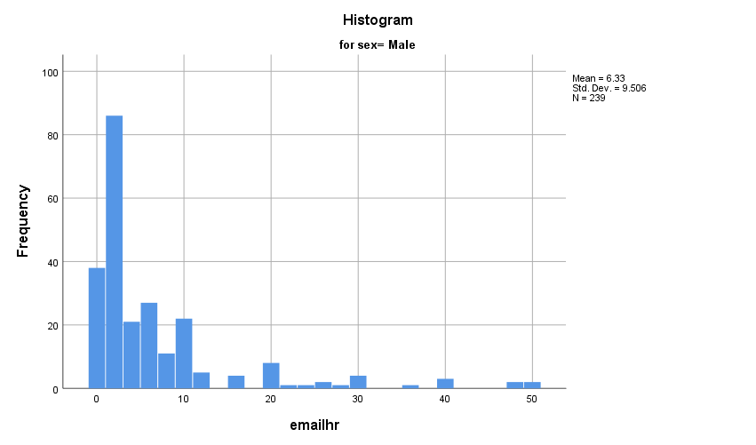

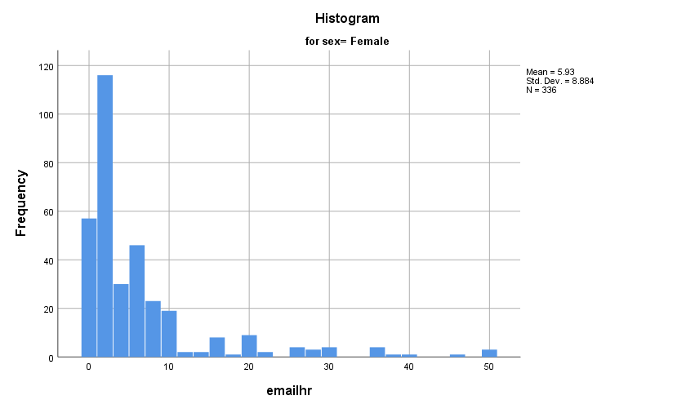

Stem-and-Leaf Plots

emailhr Stem-and-Leaf Plot for
sex= Male

Frequency Stem & Leaf

38.00 0 . 00000000000000000000000000000000000000
48.00 1 . 000000000000000000000000000000000000000000000000
38.00 2 . 00000000000000000000000000000000000000
10.00 3 . 0000000000
11.00 4 . 00000000000
21.00 5 . 000000000000000000000
6.00 6 . 000000
7.00 7 . 0000000
4.00 8 . 0000
2.00 9 . 00
20.00 10 . 00000000000000000000
.00 11 .
5.00 12 . 00000
.00 13 .
.00 14 .
4.00 15 . 0000
25.00 Extremes (>=20.0)

Stem width: 1
Each leaf: 1 case(s)

emailhr Stem-and-Leaf Plot for
sex= Female

Frequency Stem & Leaf

57.00 0 . 000000000000000000000000000000000000000000000000000000000
68.00 1 . 00000000000000000000000000000000000000000000000000000000000000000000
48.00 2 . 000000000000000000000000000000000000000000000000
16.00 3 . 0000000000000000
14.00 4 . 00000000000000
39.00 5 . 000000000000000000000000000000000000000
7.00 6 . 0000000
15.00 7 . 000000000000000
8.00 8 . 00000000
1.00 9 . 0
18.00 10 . 000000000000000000
.00 11 .
2.00 12 . 00
.00 13 .
2.00 14 . 00
8.00 15 . 00000000
33.00 Extremes (>=18.0)

Stem width: 1
Each leaf: 1 case(s)

Normal Q-Q Plots

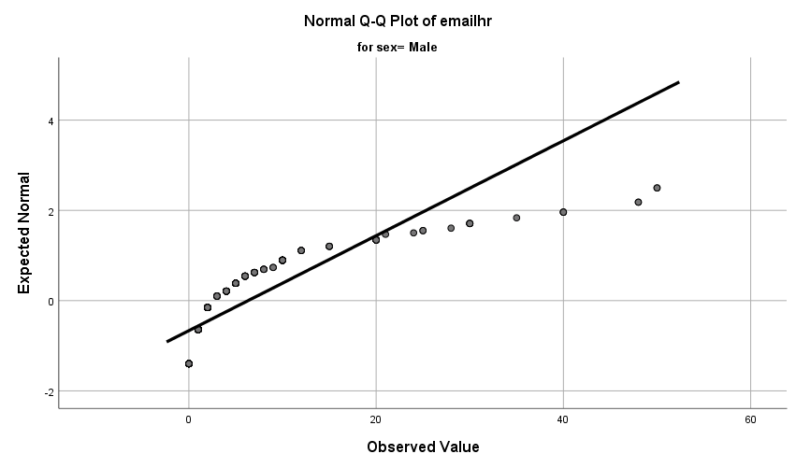

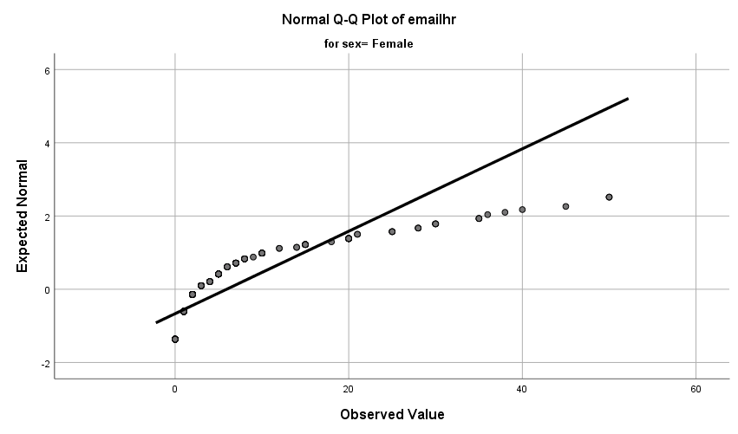

Detrended Normal Q-Q Plots

